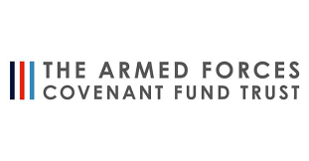
Total amount allocated: £18,000
Total amount spent: £30,108

Upton Westlea Primary School
2022/2023
The Armed Forces Covenant Fund Trust

We have used the funding provided to appoint a child and parent support officer.

Key achievements to date:
- Enrichment Clubs
- Organised 1-2-1 sessions with a charity, ‘Passion for Learning’
- Drop in sessions for parents to discuss any issues or concerns
- Support of year 6 children to high school
- Regular liaisons with army welfare
- Supporting new families coming in

