

Eden

The Resourced Provision at Upton Westlea for children with a diagnosis of ASC.

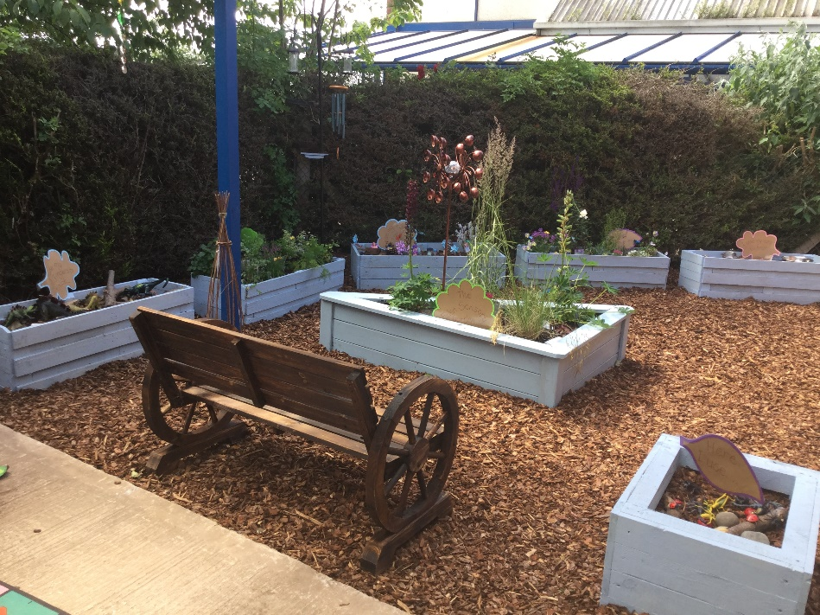

Teacher in charge: Mrs L Wright

*“Welcome to Eden, our Resourced Provision for children with ASC.*

*I am Mrs Wright and I am the class Teacher within the Resourced Provision Class.  We are lucky to have a fantastic team of staff that support within the provision:*

*Teaching Assistants Mrs Carline, Mrs Gerrard and*

*Mrs Gittins*

*Mr Ellinson leads the class for Forest School. We occasionally have additional staff depending on the activity.*

*We are proud to share this bespoke environment where we focus heavily on personalised learning to create an environment that all our children can thrive in.*



Eden is our 10 place resourced provision at Upton Westlea for children with a diagnosis of Autism, also known as ASC or ASD. Places within Eden are allocated by the SEN assessment and monitoring team at Cheshire West and Chester. All children who are allocated a place have a diagnosis and a Statement or EHCP (Education Health and Care Plan).

Eden is based within the mainstream school of Upton Westlea. All pupils will be registered with a mainstream class and may: be part of this class for whole school activities such as Assemblies, Christmas Productions and School Trips, as deemed appropriate by the specialist teacher and in conjunction with the class teacher. The criteria for Eden is that every child should be able to integrate into mainstream at a level that is suitable for them. We have the aspiration that every child will be fully integrated by Year 6 (up to 65% of the week), however, this is very much down to the individual child and will be in consultation with parents and staff. All pupils will be supported by members of staff either in Eden class or in the mainstream classroom depending on the individual child’s need. No child will be expected to cope in a situation they are finding too difficult.

A Speech and Language Therapist is attached to Eden who supports the children through assessment, intervention, one to one and small group work, programme planning, social skills and much more. We have ensured that all members of the school community from teachers, to Mid Day assistants, to Governors have had training in ASC and the teaching methods and strategies which best allow the children to achieve at school have been shared. The members of Eden staff have undertaken additional training and qualifications in the field of ASC.

An Education, Health and Care Plan(EHCP) is for children and young people up to 25 who need more support than is available through special educational needs support.

EHC plans identify Educational, Health and Social Needs and set out the additional support to meet those needs.

Within Eden, staff work as a skilled and experienced team to meet the needs of every child and use the information from each child’s EHCP to create their own bespoke personalised curriculum. This is reflected in the child’s Individualised Learning Web. Parents are integral in this process and have the opportunity to add their own targets and aspirations for their child each term. This is then reviewed in Termly parent’s meetings in addition to an Annual Review.

**Eden, the learning environment**

All staff are encouraged to adopt a calm tone of voice with the children in Eden and share the ethos:

**“When children are overwhelmed by big emotions, it is our job to share with them our calm, not join their chaos.”**

Staff use their expertise to ensure all children are alert, organised and ready to learn. They are fully aware of how the children need to develop a sensory diet and bespoke strategies are implemented, according to individual needs. As a specialist team, we meet regularly to review learning and share good practice.

**Teaching and Learning**

In Eden, children are taught using a thematic, multi-sensory approach to learning. We constantly strive to engage children in a broad and balanced curriculum, whilst prioritising the aims of the individual EHCPs. We aim to base learning around quality texts and provide learning experiences that are pitched to their individual needs and interests. We are aspirational in our expectations and we strive for children to reach their full academic, personal, social and emotional potential.

**Personalised Learning in Eden**

All children have a ‘Pupil Passport’ and an ‘Individualised Learning Web’. Parents are involved in this process and provide school with an ‘All about me’ sheet that details interests, anxiety triggers and other personalised information. Parents are heavily involved in the input for the Individualised Learning Webs and have opportunities to make changes and add their own aspirations and targets. This is reviewed at various points throughout each Term.

Some staff will use the Personalised Learning Webs when supporting the class teacher. All staff play a key role in the monitoring and assessment of every child. When a child has demonstrated a skill 6 times, we believe they have achieved it. However, this is at the discretion of the class teacher, as every child is looked at individually. Staff will also write ‘Hot Targets’ observations in both Eden and the mainstream class and they will be presented in books.

**Behaviour in Eden**

We want Eden to be a happy, calm environment where every child has the right to learn. In the provision classroom, we have a system of sanctions are rewards to manage behaviour:

We have a clear ‘working for’ approach, where children earn tokens for each part of their day. This is motivational for the children and aims to encourage children to follow adult lead activities.

**Rewards:**

We praise and reward children for good behaviour in a variety of ways:

* Working for approach – children are rewarded with short amounts of ‘choosing time’ when they complete allocated tasks. This is cumulative and can be very empowering for the children to take ownership of their own actions.
* Adults praise children by labelling the positive behaviour that is displayed.
* Class dojos are given out.
* Golden time – 30 minutes to take part in a class decided treat e.g DVD, trip to the café or park.
* Certificates – children receive certificates for various achievements.

Sanctions:

* First step
* Remind the child of the rules
* State clearly what the expectation is
* First warning
* Say “I need you to choose to…. or you will choose to have a sad face.
* Provide the child with an alternative choice of activity or behaviour.
* The child is made to feel in control of their choice.

_ Children are shown visuals that encourage them to feel that they can ‘turn their choices around’.

* Final Step

Say “You have chosen to …… that means you have chosen to have a sad face on your chart”

A sad face=1 minute loss of choosing time.

Children within Eden may require positive handling from time to time. Please refer to our school Positive Handling policy. We follow the following steps:

1. Children will be given a verbal request.
2. Children will be provided with a symbol or visual to support the verbal request where needed.
3. Children will be positively handled and encouraged to follow the original verbal request.

N.B Parents are consulted on this process when starting in Eden.

**Team Teach**

All staff within Eden have been trained in Team Teach. We strive to be proactive in our approach to behaviour management and foster a positive learning environment where all children feel safe.



***Our aim: through the promotion of de-escalation strategies and the reduction of risk and restraint, to support teaching, learning and caring, by increasing staff confidence and competence, in responding to behaviours that challenge, whilst promoting and protecting positive relationships. Positive Behavioural Support (PBS) approaches are entirely compatible with Team-Teach.***

* To promote the least intrusive positive handling strategy and a continuum of gradual and graded techniques, with an emphasis and preference for the use of verbal, non-verbal de-escalation strategies being used and exhausted before positive handling strategies are utilised.
* To enable services develop acceptable and authorised responses to disruptive, disturbing, angry and aggressive behaviours in a manner that maintains positive relationships and provides safety for all, by training in Team-Teach.
* To reduce the amount of serious incidents involving physical controls in all settings and to emphasise the importance of exhausting behaviour management strategies in the first instance.
* To increase the awareness of staff concerning the importance of recording and reporting, monitoring and evaluating, all incidents involving positive handling.
* To provide a process of repair and reflection for both staff and children.

**Exceptional Circumstances**

If a child demonstrates any of the following behaviours, then that member of staff may override the steps in the policy and the child will receive an automatic sad face for their chart. This means that they will miss 1 minute of their choosing time. Such behaviours include:

* Hitting / Fighting
* Damaging property
* Endangering others
* Rudeness / bad language to pupils / teacher

**Outside agencies**

As staff we work alongside outside agencies to ensure that we are supporting children in the best possible way.

The Speech and Language Therapist, working with the teacher, designs a Speech and Language Programme which contains both short and long term objectives. The children receive weekly therapy and then staff deliver ‘carry over’ tasks suggested by the Speech Therapist.

We also liaise with Paediatricians, Occupational Therapists, Dieticians and other outside agencies. We use their professional recommendations to feed into the individual child’s personalised learning plan.

**Bullying**

Bullying is an important issue for all pupils but children and young people with Autism are particularly vulnerable. The staff in Eden are proactive in staying up to date with the latest training in supporting children with Autism in this way. We work closely with mainstream staff to ensure we follow our whole school policy. Children in Eden are taught about Bullying and the impact on themselves and others at key opportunities that are appropriate to the group/individual child.

**The Annual Review**

Each child will have an Annual Review of the EHCP of Special Educational Needs. At this meeting progress is reviewed and we make a joint decision if the child’s needs are being made within Eden class. This review is led by Mrs Wright, the specialist teacher in Eden and the child’s mainstream class teacher, parents and any outside agencies involved with the child will be asked to attend.